**COMP 3123 – Full Stack Development – Lab 5**

**GET /home Output Screenshot**

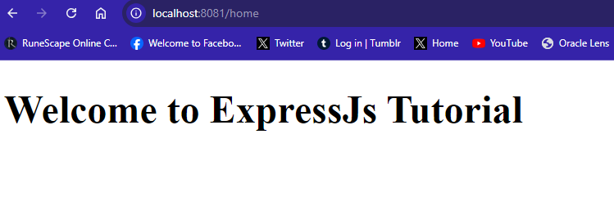

**GET /profile POSTMAN Output screenshot**

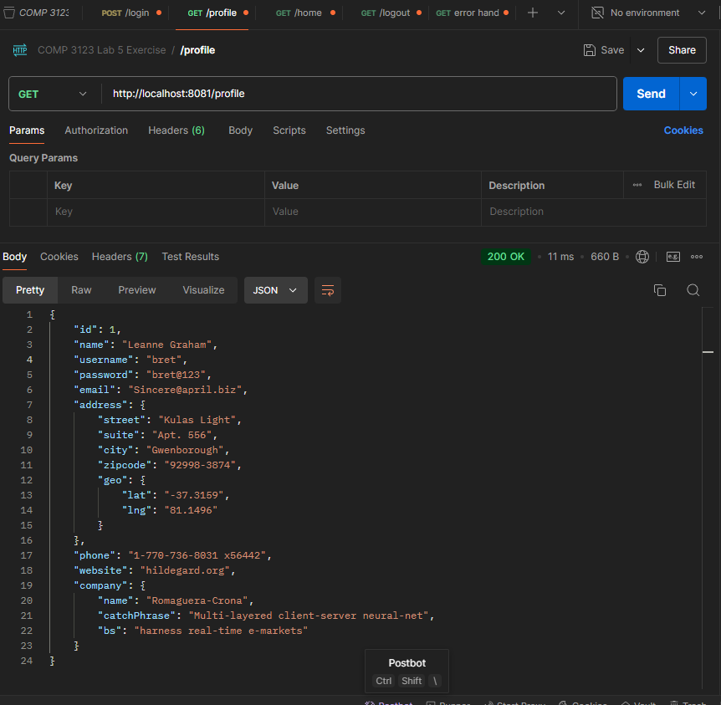

**POST /login POSTMAN Output Screenshot**

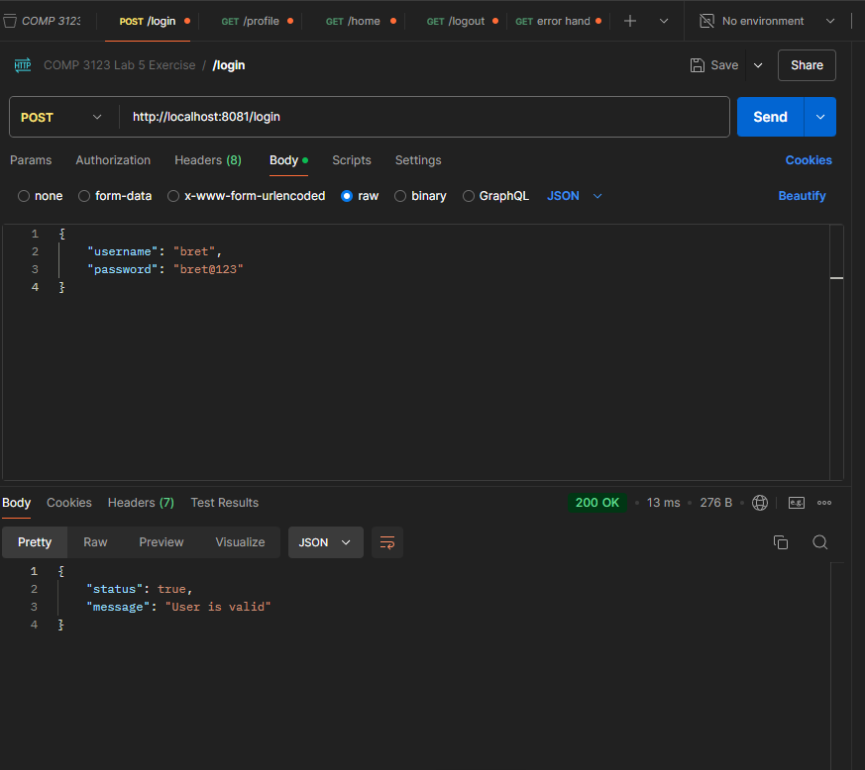

**GET /logout POSTMAN Output Screenshot**

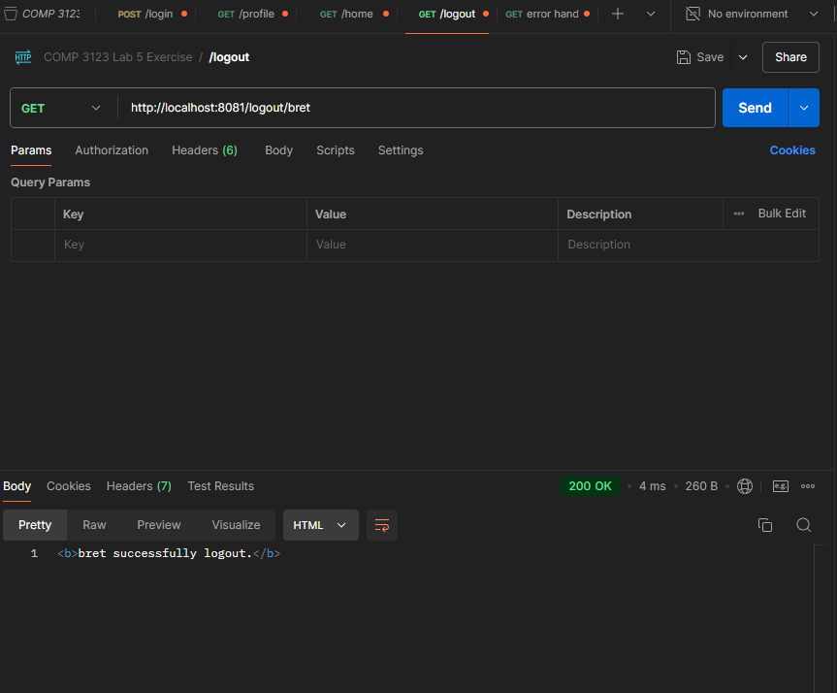

**GET /profile Error Handling Output Screenshot**

